# Abstract

Institutional internal audit is the MQA process which will test the quality of the courses of study; the standards of awards and internal procedures for securing quality and standards. Currently in UniKL, there is no information system and they use individual spreadsheet files to capture processes and analyze data as well to generate general reports. Therefore, this project aims to develop an information system for institutional internal audit which involves capture, calculation, integration and generate audit data and results, required by the institutional internal audit processes. The methodology that will be used throughout the project is Agile Development Cycle. It consists of a series of iterations, analyzing, designing, developing and testing each feature in turn within the iterations. This cycle includes the stakeholders throughout the development of the system. This project will include detailed modules including authorization, assessment input, assessment criteria, score’s calculation and reporting and analysis.

**Table of Contents**

Abstract i

1 INTRODUCTION 1

1.1 Introduction 1

1.2 Research background 1

1.3 Problem statement 2

1.4 Research objectives 2

1.5 Scope of research 3

1.5.1 Scope of user 3

1.5.2 Scope of system 3

2 LITERATURE REVIEW 4

2.1 Introduction 4

2.2 Institutional audit in university in Malaysia 4

2.2.1 Overview 4

2.2.2 Malaysian quality assurance system for higher education 4

2.2.3 Instrument in institutional audit for MQA 4

2.3 Ways of auditing the evaluation 5

2.3.1 Documents review 5

2.3.2 Using spreadsheets in Excel 5

2.4 Review on existing system for audit system 6

2.4.1 Overview 6

2.4.2 MetricStream Audit Management Software Solution 6

2.4.3 MKinsight 7

2.4.4 Campus Café 8

2.4.5 Academic Audit-Computing Services 9

2.4.6 Features of the existing software for audit system 11

2.5 Summary 11

3 RESEARCH METHODOLOGY 12

3.1 Introduction 12

3.2 Agile 12

4 Bibliography 14

# INTRODUCTION

## Introduction

This chapter focuses on the research background, problem statement, research objectives, significance and scope of research.

## Research background

Institutional internal audit is the Malaysian Qualification Agency (MQA) process which will test the quality of the courses of study; the standards of awards and internal procedures for securing quality and standards. According to Quality Assurance Agency for Higher Education (2016), institutional audit will focus on the quality and transparency of information provided to students; the ways in which their learning is facilitated and supported, and the academic standards they are expected to achieve, and achieve in practice.

In University Kuala Lumpur (UniKL), the auditors are still implementing the use of spreadsheet excel for documentations and using a stand-alone system to gather all data by years until now. Each of the auditors has to fill in the form and have a problem in redundancy and overwriting the old information manually (Mokhtar, 2016). By this, they have to face the problems of losing history if they do not save the document or template in a proper way.

The aim of this project was to create a new platform for internal that can measure the level of quality in such a flexible way that it can incorporate various types of quality audit.

## Problem statement

According to Mokhtar (2016), there is no information system to capture, process and analyze data as well to generate general reports. Currently, the university is using individual spreadsheet files to capture and analyze the data.

On these matters, there are too many errors with regards to the formula for calculation. Plus, it is difficult to integrate past and future reports to have a comprehensive as required by the university. The existing spreadsheet does not allow detailed comment instead they have to type manually inside the Word.

Due to this, there are too many errors, very tedious in terms of copy and paste, time consuming and takes a lot of effort.

## Research objectives

The aim of the research is to develop an information system for institutional internal audit which involves capture, calculate, integrate and generate audit data and results, required by the institutional internal audit processes. Therefore, the objectives of the research are:

1. To identify the requirements for the information system based on the needs of the institutional internal audit
2. To design presentation layer, business layer (calculation, store and keep) and data layer (database) for the information system (3-tier architecture)
3. To develop an information system that can capture, calculate, integrate and generate an audit data and results
4. To conduct test and deploy the information system

## Scope of research

### Scope of user

Institutional internal audit information systems will only be used by administrators and auditors of UniKL that are involved in the MQA process.

### Scope of system

Institutional internal audit information system will cover detailed modules including authorization, assessment input, assessment criteria, score’s calculation and reporting and analysis. The formula for calculation used in the system is based on what is included within the current system without being changeable.

# LITERATURE REVIEW

## Introduction

A literature review is an account of what has been published on a topic by accredited scholars and researchers. Literature review can be just a simple summary of the sources, but it usually has an organizational pattern and combines both summary and synthesis. This chapter covers the system process involved in institutional internal audit, the purpose, existing applications that are related to the topic and their features.

## Institutional audit in university in Malaysia

### Overview

Institutional internal audit will help the university meet the demands of creating a more educated Malaysian. According to StudyMalaysia.com (2012), MQA has set a basis for quality assurance of higher education and as the reference point for the criteria and standards for national qualifications. The MQA was developed to unify and harmonize all Malaysian qualifications.

### Malaysian quality assurance system for higher education

The Malaysian Qualifications Agency (MQA) has developed guidelines for Institutional Audit (Code of Practice for Institutional Audit, COPIA) as well as for discipline-specific standards (Malaysian Qualification Agency, 2014). These guidelines set out good practices of evaluation relating to the structure and processes of Malaysia’s higher education system. One of the processes involved in this is internal audit.

### Instrument in institutional audit for MQA

This “Evaluation instrument for Institutional Audit” is specifically directed for purposes of institutional audit (Malaysian Qualification Agency, 2014). The instrument is designed to measure the level of quality in such a flexible way that it can incorporate various types of quality audit. The instruments provide guidelines on general requirements in the following areas:

1. Vision, mission and learning outcomes;
2. Curriculum design and delivery;
3. Student selection and support services;
4. Assessment of students;
5. Academic staff;
6. Educational resources;
7. Programme monitoring and review;
8. Leadership, governance and administration; and
9. Continual quality improvement

## Ways of auditing the evaluation

University in Malaysia have been practicing the guidelines provides by MQA since in the mid-1990s, when higher education was rather limited in scope and numbers, and confined to mainly public institutions, quality issues were handled internally by the public universities through its quality assurance mechanism and monitored by the Ministry of Education (StudyMalaysia.com, 2012). This practice is applied manually using a bunch of papers in the beginning, then changed into documents where the era of the computers are starting more likeable and affordable to buy at the time.

### Documents review

Auditors once are using documents that are printed from computers and they have to fill all the scores and calculate the scores manually (Mokhtar, 2016).This traditional method might have some errors due to different formulas in each area. After they complete the audit, the papers will be obsolete or in some cases, might be thrown away and will never get it back.

### Using spreadsheets in Excel

Excel 2010 is giving some excellent components for users to do a table using cells and do the formula and calculation in formula bar (GCF LearnFree.org, 2016). Different sheets are set with different formulas. However, the system is not online and the auditors cannot share the documents with others unless they are using apps like Drive or Dropbox to be accessible by other auditors.

## Review on existing system for audit system

### Overview

Here in UniKL, there is still no locally developed institutional audit that focuses only on the internal parts that involve MQA where it is always confidential to be seen by other staff of UniKL. However, there are a number of systems and software that include audit as a main concepts for audit but did not focus on academic and institution.

The following sections discuss some of the main features provided by three systems/ software for auditing, entitled ‘MetricStream Audit Management Software Solution’, ‘MKinsight’, ‘Campus Café’ and ‘Academic Audit-Computing Services’.

### MetricStream Audit Management Software Solution

MetricStream Audit Management Solution is designed to help companies manage a wide range of audit-related activities, data, and processes in a single, comprehensive framework, including internal audits, operational audits, IT audits, supplier audits, and quality audits (MetricStream Inc., 2016).The software provide an offline audit functionalities that allow organizations to implement industry best practices for efficient audit execution, and ensure integration of the audit process with better risk management and compliance management system. The overview of the software is shown in Figure 2.1.

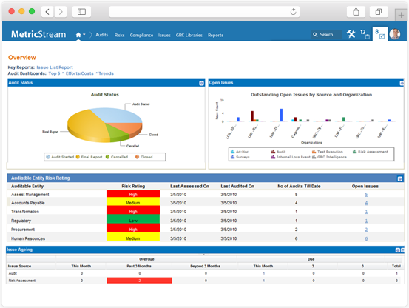

**Figure 2.1 Overview of MetricStream Audit Management Solution**

### MKinsight

MKinsight is an audit management system that is used widely by individual auditors to State Audit Institutions. The system can set the roles based on privileges for user restriction (Morgan Kai Group, 2016). Mkinsight is a fully configurable Audit Management System that provides comprehensive functionality in the following components: audit management, recommendation/ action tracking, comprehensive reporting, questionnaires and surveys, etc. The overview of the software is shown in Figure 2.2.

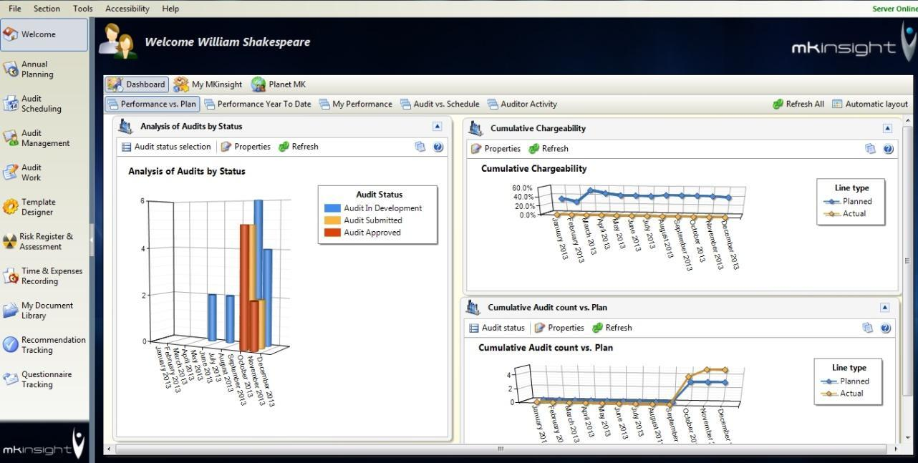

**Figure 2.2 Overview of MKinsight**

### Campus Café

This software is specially built for Higher Education where the software provides a single database student information system that unifies the admission, student services/activities, business office and alumni functions (Campus Café Software, 2016). The software lets the user edit their profiles and user Id of person.

However, the software was designed for educational institutions with fewer than 10,000 students, yet providing you with a cost-effective solution. Implementations are quick and updates are more efficient. It does not require a large internal staff to support, so the cost structure is lower. The overview of the software that is made especially for Indus Institute of Higher Education is shown in Figure 2.3.

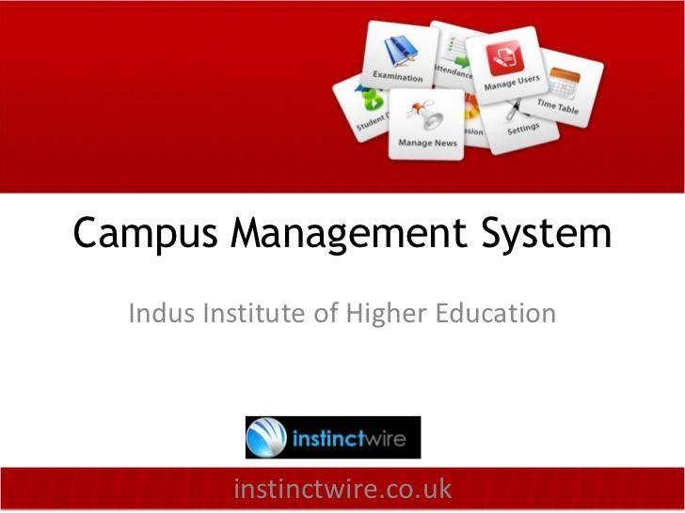

**Figure 2.3 Overview of Campus Café**

### Academic Audit-Computing Services

The Academic Audit application is made for Carnegie Mellon University and accessible by an approved subset of academic department administrators and is used to compare the courses from academic records against degree requirements. The system can plan a schedule for a future semester, determine remaining requirements in a current major, and also determine remaining degree requirements when considering a transfer from one major to another (Carnegie Mellon University, 2016). The system is available for Windows, Linux and Mac OS X. Also, it allows remote control access with high security. The overview of the software is shown in Figure 2.4.

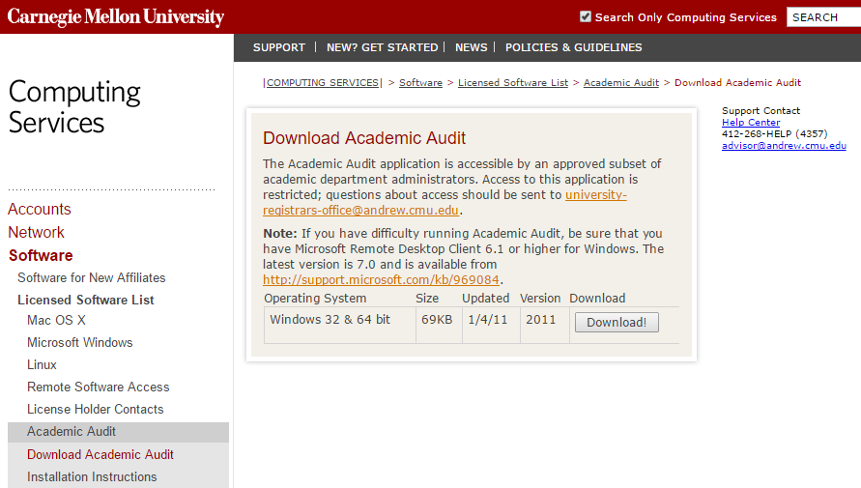

**Figure 2.4 Overview of Academic Audit-Computing Services**

### Features of the existing software for audit system

Features of the existing software for the audit system were studied and used as guidelines in the selection of features to be included in Institutional Internal Audit Information System. Table 2.1 shows the main features of the existing applications for the audit system.

**Table 1 Main features of the existing applications for audit system**

|  |  |  |  |  |  |
| --- | --- | --- | --- | --- | --- |
|  |  | Existing applications | | | |
|  |  | MetricStream Audit Management Software Solution | MKinsight | Campus Café | Academic Audit-Computing Services |
| Features | Profile services | None | None | Available | Available |
| Assign roles | Available | Available | Available | Available |
| Analysis and reporting | Available | none | Available | Available |
| Time Tracking | Available | Available | None | Available |

## Summary

This chapter presents investigations on audit systems based on software that are available in markets today. A relevant understanding of the related issues is important in order to develop a system which is not fully developed by institutions in Malaysia. From the case study, it was found that most of the software do cover more on business compared to academics due to higher demands.

# RESEARCH METHODOLOGY

## Introduction

Research methodology is the process used to collect information and data for the purpose of making business decisions (BusinessDictionary.com, 2016). It is often necessary to include a consideration of the concepts and theories which underlie the methods. This chapter elaborates Agile methodology and the process of each of its phases.

## Agile

In terms of time scale, agile is approximately a good practice as guidelines in the project. Agile SDLC model is a combination of iterative and incremental process models with focus on process adaptability and customer satisfaction by rapid delivery of working software products (tutorialspoint, 2016).

Agile development methodology provides opportunities to assess the direction of a project throughout the development lifecycle. This is achieved through regular cadences of work, known as sprints or iterations, at the end of which teams must present a potentially shippable product increment. By focusing on the repetition of abbreviated work cycles as well as the functional product they yield, agile methodology is described as iterative and incremental. In waterfall, development teams only have one chance to get each aspect of a project right. In an agile paradigm, every aspect of development; planning, requirements, design, deployment and testing is continually revisited throughout the lifecycle. When a team stops and re-evaluates the direction of a project every two weeks, there’s always time to steer it in another direction.

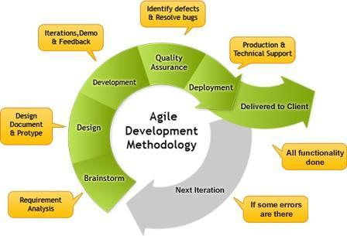

**Figure 3.1 Stages of Agile**

# Bibliography

BusinessDictionary.com. (2016). *What is research methodology? definition and meaning*. Retrieved from BusinessDictionary.com: http://www.businessdictionary.com/definition/research-methodology.html

Campus Café Software. (2016, April). *Audit trails capability for school management software*. Retrieved from Campus Management Software - Higher Education: https://campuscafesoftware.com/products/audit-trails/

Carnegie Mellon University. (2016). *Download Academic Audit-Computing Services*. Retrieved from Homepage - CMU: https://www.cmu.edu/computing/software/all/acadaudit/download.html

GCF LearnFree.org. (2016, May). *Excel XP: Identifying Basic Parts of the Excel Window*. Retrieved from Free Online Learning at GCFLearnFree: http://www.gcflearnfree.org/excelxp/1/print

Malaysian Qualification Agency. (2014). *Introduction to Academic Standards.*

MetricStream Inc. (2016, May). *Audit Management and Tracking System | Audt System.* Retrieved from Governance, Risk and Compliance (GRC), Quality Management Software Solutions - MetricStream: http://www.metricstream.com/solutions/audit-management.htm

Mokhtar, S. A. (2016, February). Institutional Internal Audit Information System. (A. N. Azman, Interviewer)

Morgan Kai Group. (2016, April). *MKinsight - web based Internal Audit Software*. Retrieved from MKinsight Internal Audit Software: http://www.mkinsight.com/functionality.aspx?id=22

Quality Assurance Agency for Higher Education. (2016). *What is institutional audit paper.* United Kingdom.

StudyMalaysia.com. (2012, October 2). *Malaysian Qualifications Agency (MQA).* Retrieved from StudyMalaysia Network: https://www.studymalaysia.com/education/art_govn.php?id=agencies5

Taylor, D. (2016, March). *The Literature Review: A Few Tips On Conducting It*. Retrieved from Writing at the University of Toronto: http://www.writing.utoronto.ca/advice/specific-types-of-writing/literature-review

tutorialspoint. (2016, April). *SDLC - Agile Model*. Retrieved from Tutorials for MFC, SAP, HR, Yii, etc: http://www.tutorialspoint.com/sdlc/sdlc_agile_model.htm